Checking Study Activation Progress the Task List in OnCore
In order to review the progress of a Study activation by OCTA in OnCore, Study teams look at the Task List in the OnCore Protocol record for their Study.

Access the Task List
- Navigate to appropriate Protocol record.

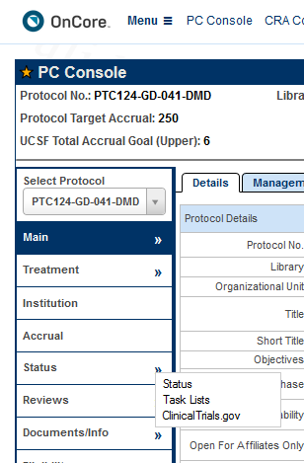
- In the PC Console, click the
  - chevron in the Status vertical tab
  - then the Task List horizontal tab

a
b

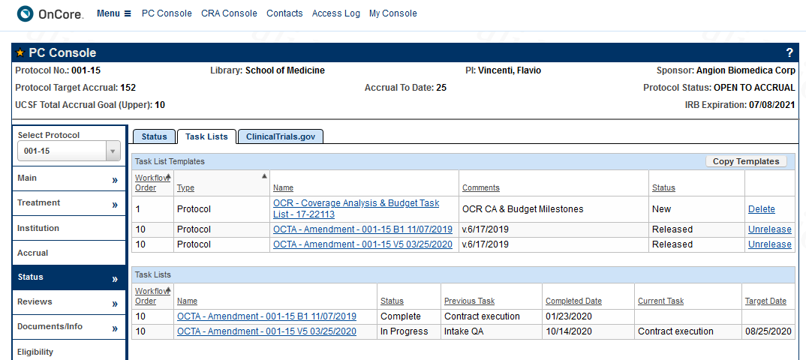
- Locate the Task List with “In Progress’ status
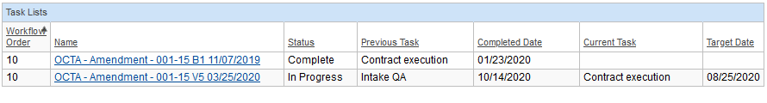
- The Previous Task Column indicates the last completed Task List step, and the Current Task column shows the current, incomplete Task List step.

- Click the In-Progress Task List hyperlink to open the Task List window.
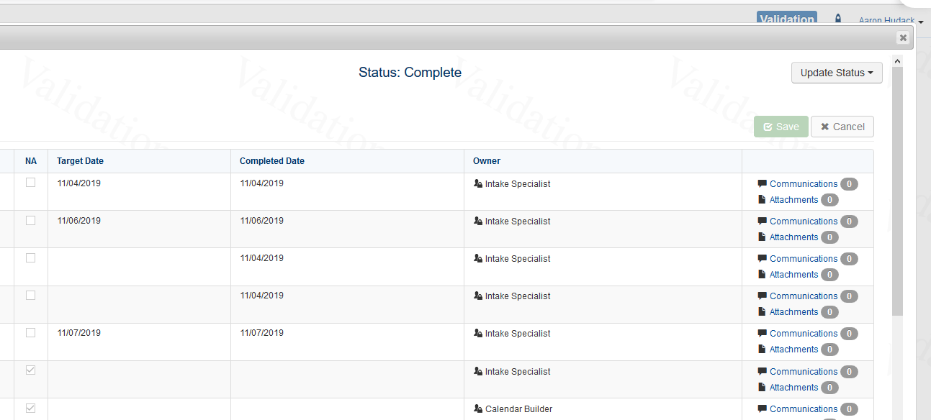
- Click the Communications hyperlink to view communications with the desired OCTA staff.

- To find the name of the listed OCTA Staff, go to the PC Console>Main vertical tab>Staff horizontal tab, sort by Role, and scroll to the OCTA staff member.
