How Does a Coverage Analysis (CA) Work?
No Coverage Analysis in Place
(Non-Clinical Research Billing)
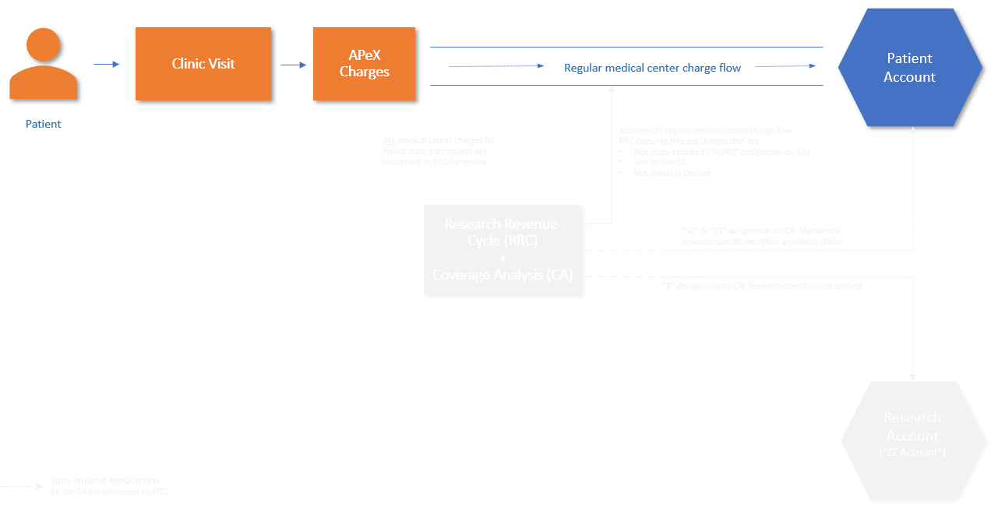

All patients’ medical center charges automatically flow to the patient/payor.

How Does a Coverage Analysis (CA) Work?
Coverage Analysis in Place
(Clinical Research Billing)
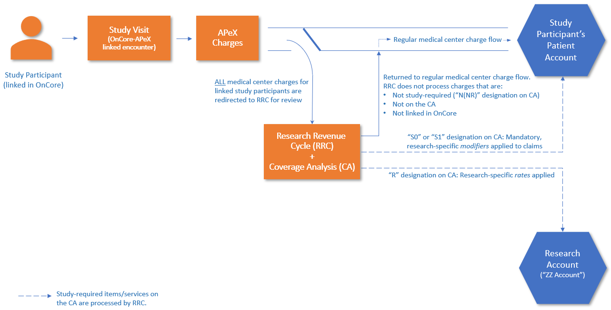

All linked study participants’ charges are redirected to the Research Revenue Cycle (RRC) Team for review. The RRC Team references the CA to guide them on how to direct the charges. If an item/ service is not on the CA, then it is assumed it is not required by the study and tossed back into the medical center’s non-clinical research billing flow.

